**Lab 5 Screenshot**

**DBConnectionPane.jar:**

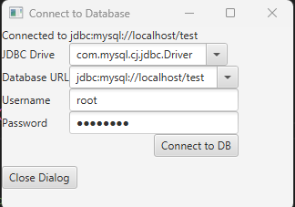

**Output:**

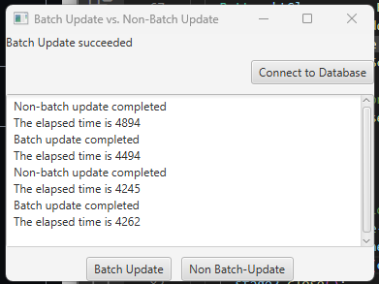

**Extra Credit:**

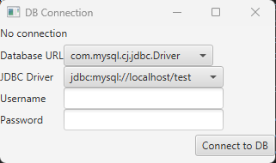

**Connecting to Database:**

